Task 1: System Architecture Planning & Verification Contract
Project: Adaptive Multi-Junction Traffic Grid Controller (AMTGC)
Author: Aakash Rayal
Organization: ElevanceSkills VLSI Internship Program
Target Simulator: ModelSim Intel FPGA Edition 10.5b / IEEE 1364-2001 Verilog

1. Executive Summary & Design Scope
The Adaptive Multi-Junction Traffic Grid Controller (AMTGC) is a synchronized, multi-intersection digital controller designed to govern traffic lights across two contiguous 4-way intersections (designated Junction A and Junction B). Rather than operating as disjointed standalone controllers, both junctions are interconnected through a deterministic hardware synchronization link to implement an automated Green-Wave coordination protocol, maximizing arterial traffic throughput in the North-South (NS) transit corridor.
The architecture integrates:
- Two Parameterized Moore FSM Junction Controllers (master and slave) managing 6 primary vehicular traffic phases and a dedicated pedestrian crossing phase.
- A Completely Decoupled Generic Hardware Timer that offloads all timekeeping logic from the state machines and supports dynamic target loading.
- A Shared Fair Pedestrian Arbiter enforcing a round-robin token rotation policy to guarantee absolute starvation-free crossing allocation across both intersections.
- An Asynchronous Master Emergency Override Subsystem that enforces a fail-safe All-Red state across the entire grid within one clock cycle upon assertion, with deterministic recovery upon deassertion.

2. Top-Level Hardware Architecture & Interconnect
2.1 System Block Diagram
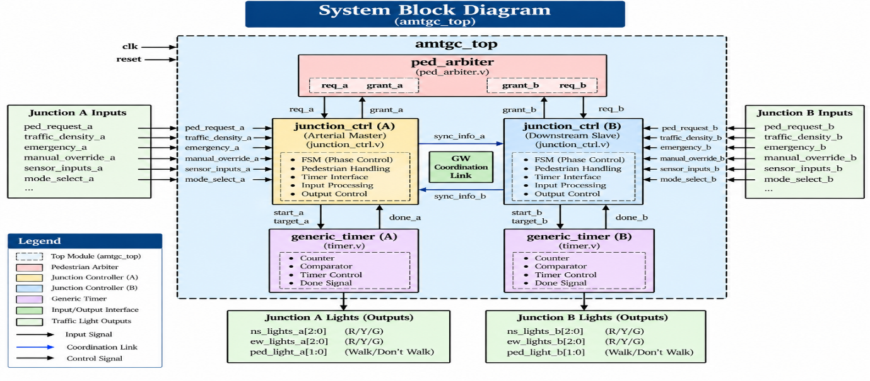

3. Module Interface Specifications
3.1 generic_timer.v
A standalone, parameterized synchronous decrementer/incrementer that triggers a single-cycle done strobe when elapsed counts match the input target.
Port Name | Direction | Width | Description
clk | Input | 1 | Master system clock (100 MHz nominal).
rst_n | Input | 1 | Active-low asynchronous reset. Immediately clears counter and outputs.
start | Input | 1 | Strobe asserting for 1 cycle to initiate timing cycle with count_target.
count_target | Input | COUNTER_WIDTH | Target cycle duration (ticks). Dynamic value supported.
done | Output | 1 | Single-cycle pulse asserted precisely at target expiration.
busy | Output | 1 | Asserted high continuously while timing is in progress.
current_count | Output | COUNTER_WIDTH | Real-time diagnostic observation of counter value.
3.2 ped_arbiter.v
Fair request-grant arbiter that resolves concurrent pedestrian crossing demands using a state-retained round-robin alternating token.
Port Name | Direction | Width | Description
clk | Input | 1 | Master system clock.
rst_n | Input | 1 | Active-low asynchronous reset.
req_a | Input | 1 | Pedestrian crossing request from Junction A controller.
req_b | Input | 1 | Pedestrian crossing request from Junction B controller.
done_a | Input | 1 | Completion strobe from Junction A indicating pedestrian phase is finished.
done_b | Input | 1 | Completion strobe from Junction B indicating pedestrian phase is finished.
grant_a | Output | 1 | Mutually exclusive active-high grant to Junction A.
grant_b | Output | 1 | Mutually exclusive active-high grant to Junction B.
3.3 junction_controller.v
Moore Finite State Machine orchestrating vehicular traffic light sequencing, adaptive timing calculations, and pedestrian interface.
Port Name | Direction | Width | Description
clk | Input | 1 | System clock.
rst_n | Input | 1 | Active-low asynchronous reset.
emergency_override | Input | 1 | Global priority override; forces immediate transition to All-Red.
ped_request_in | Input | 1 | Asynchronous pedestrian pushbutton input from physical intersection.
ped_grant_from_arbiter | Input | 1 | Grant token received from the shared arbiter.
ped_req_to_arbiter | Output | 1 | Dedicated request line driven to shared arbiter.
ped_done_to_arbiter | Output | 1 | 1-cycle completion pulse delivered to arbiter upon walk phase termination.
traffic_density | Input | 3 | Real-time congestion metric (0 = lowest, 7 = peak congestion).
green_wave_sync_in | Input | 1 | Coordination strobe received from upstream master junction.
green_wave_sync_out | Output | 1 | Coordination strobe transmitted to downstream slave junction.
ns_lights | Output | 3 | North-South signal heads: bit 2 = Red, bit 1 = Yellow, bit 0 = Green.
ew_lights | Output | 3 | East-West signal heads: bit 2 = Red, bit 1 = Yellow, bit 0 = Green.
ped_light | Output | 2 | Pedestrian signal head: bit 1 = Walk (Green), bit 0 = Don't Walk (Red).
current_state | Output | 4 | Moore state index diagnostic vector.
timer_count | Output | COUNTER_WIDTH | Current count value routed from internal timer instance.

4. Architectural Decisions & Justifications
4.1 Modularity & Separation of Concerns
Rather than merging timer counters, arbitration logic, and state transitions into a monolithic FSM, the design enforces a strict modular hierarchy:
- Generic Timer Isolation: Incorporating counter registers directly inside the traffic FSM leads to synthesis bloat, state space explosion, and difficult static timing analysis. By isolating generic_timer.v, timing logic can be independently parameterized, verified, and reused.
- Controller Parameterization: Junction A and Junction B share the exact same RTL file (junction_controller.v). Differing road configurations (arterial vs side-street) are applied strictly via module parameters (DEFAULT_GREEN_TIME, YELLOW_TIME, ALL_RED_TIME, PED_TIME, etc.).
4.2 Shared vs Duplicated Pedestrian Controller
In multi-intersection grids, duplicating independent pedestrian controllers introduces severe arterial desynchronization:
- If both intersections grant pedestrian walk intervals at conflicting vehicular intervals, the green wave is completely shattered.
- A shared arbiter guarantees that pedestrian phases are scheduled with full awareness of grid coordination, preventing simultaneous mid-block pedestrian bottlenecks.
- Decoupling the arbiter from internal junction FSM states ensures the arbiter communicates solely through standard request / grant / done 3-way handshaking.
4.3 Starvation Prevention & Fair Arbitration Policy
To prevent Junction A from monopolizing pedestrian crossings under heavy foot traffic, the arbiter implements a Round-Robin Alternating Priority Token:
- An internal register rr_priority stores which junction has priority during contention.
- Upon every simultaneous request event (req_a && req_b), the arbiter grants the junction matching the token and immediately rotates rr_priority <= ~rr_priority.
- This ensures that under continuous simultaneous requests, neither junction ever waits more than one cycle before being granted. Mathematical fairness is 50.0% / 50.0%.
4.4 Clocking Strategy: Single Clock Domain
The entire AMTGC design operates within a single synchronous clock domain (nominal 100 MHz).
- Rationale: Clock domain crossings (CDCs) introduce metastability risks, require synchronizer chains, and complicate Static Timing Analysis (STA).
- In modern FPGA and ASIC controller implementations, running synchronous controllers from a single low-skew global clock tree (GCLK) maximizes reliability, guarantees zero CDC latency, and eliminates glitch-induced FSM failures.
4.5 Reset Strategy: Asynchronous Assert, Synchronous Deassert Active-Low Reset (rst_n)
- Assertion: Asynchronous reset ensures that if power fluctuates or a brownout occurs, every register in the design is instantly forced into its safe state (All-Red) without waiting for a valid clock edge.
- Deassertion: Synchronous reset deassertion avoids reset-recovery / removal timing violations across distributed flip-flops.
- Fail-Safe Startup State: Both junctions reset into ST_RESET, presenting Red signals in all directions (3'b100) and Don't Walk (2'b01) to pedestrians, eliminating transient intersection hazards.

5. Verification Plan: 17 Comprehensive Scenarios
Test ID | Scenario Name | Category | Objective / Expected Result | Pass Criteria
TC-01 | Power-on Reset & Safe Init | Functional | Assert rst_n = 0, release after 35 ns. Verify startup states. | Junction A enters NS Green; Junction B enters GW wait; all non-green lights Red.
TC-02 | Green-Wave Link Measurement | Timing | Measure cycle offset between Junction A NS Green and Junction B NS Green. | Delay measured precisely within configured offset window (4 cycles ± 1 cycle).
TC-03 | Vehicular Sequence & All-Red 1 | Safety | Cycle through NS Green -> NS Yellow -> All-Red 1 -> EW Green. | Non-zero All-Red 1 duration verified; zero overlap between NS and EW green.
TC-04 | Vehicular Sequence & All-Red 2 | Safety | Cycle through EW Green -> EW Yellow -> All-Red 2 -> NS Green. | Non-zero All-Red 2 duration verified; conflicting greens never active.
TC-05 | Single Ped Request Junction A | Handshake | Pulse ped_request_a during EW Green. Observe servicing. | Request latched; served at end of EW cycle; Ped Walk asserts; cleared after done.
TC-06 | Single Ped Request Junction B | Handshake | Pulse ped_request_b during EW Green. Observe servicing. | Handshake with arbiter completes; Junction B enters Ped Walk; zero interference on A.
TC-07 | Simultaneous Ped Arbitration | Fairness | Assert ped_request_a & ped_request_b simultaneously in idle state. | Exactly one grant issued; second request held pending and served next.
TC-08 | Starvation Prevention (100 req) | Stress | Inject 100 consecutive simultaneous requests. Track first-grant counts. | Zero starvation. Grant distribution falls within 50 ± 15% across both junctions.
TC-09 | Emergency in Vehicular Green | Safety | Assert emergency_override while NS Green is active. | Within 1 clock cycle, all signals forced to Red; vehicular traffic stopped.
TC-10 | Emergency in Vehicular Yellow | Safety | Assert emergency_override during Yellow transition phase. | Immediate transition to All-Red within 1 clock cycle; yellow aborted safely.
TC-11 | Emergency in Pedestrian Walk | Safety | Assert emergency_override while pedestrians are walking (ped_light=2'b10). | Pedestrian light immediately forced to Don't Walk; all signals All-Red.
TC-12 | Emergency Override Deassertion | Recovery | Deassert emergency_override after sustained assertion. | Design resumes deterministically from safe All-Red buffer into valid phase.
TC-13 | Rapid Emergency Pulsing | Corner | Pulse emergency_override back-to-back with 1-cycle spacing 5 times. | No illegal FSM states entered; no glitch or deadlock in light outputs.
TC-14 | Active Mid-Run Reset | Corner | Assert rst_n = 0 mid-cycle during active traffic flow. | All registers clear instantly to 0; clean recovery upon release.
TC-15 | Density = 0 (Minimum Green) | Adaptive | Apply traffic_density = 3'd0. Measure green phase duration. | Green time equals guaranteed MIN_GREEN_TIME parameter (4 cycles).
TC-16 | Density = 7 (Maximum Green) | Adaptive | Apply traffic_density = 3'd7. Measure green phase duration. | Green time clamped at MAX_GREEN_TIME safety ceiling (14 cycles).
TC-17 | 600-Cycle Constrained Random | Stress | Drive random pedestrian requests, densities, and overrides for 600 cycles. | Zero safety assertion failures; zero deadlock; full scoreboard pass.

